Host Family Application and Profile
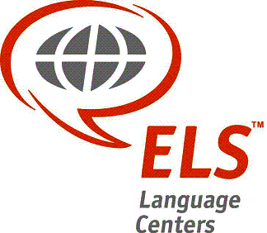

Date: __________________ Center: _________________

Host #1:
Last Name: __________________ First Name: ____________________
Gender: M or F Year of Birth: _____ Occupation: _____________

Host #2:
Last Name: __________________ First Name: ____________________
Gender: M or F Year of Birth: _____ Occupation: _____________

Address:
_______________________________________________________________________
_______________________________________________________________________

Home Telephone #: ( ) _______________ Cell#: ( ) _______________

Work#: ( ) _______________

E-mail Address: __________________________________________________________

Please list the names of everyone else living in the household, their relationship to the Host(s) [i.e. daughter, son, roommate, etc.], and their year of birth.

Name Relationship to Host Male/Female Year of Birth
________________________________________________________________________
________________________________________________________________________________________________________________________________________________________________________________________________________________________________________________________________________________________________

How many available rooms do you have? __________ How many beds? ___________

Will the student have Internet access in your home? Yes _____ No _____
If Yes, what type (high speed, wireless, dial-up)? ________________________________

What are your hobbies and interests? _________________________________________
________________________________________________________________________

Pets: Dog(s) ______ Indoor or Outdoor Cat(s) _____ Indoor or Outdoor

Additional pet information: _________________________________________________

Students will travel to and from the ELS Center by: ______________________________

Travel time from the host’s home to the ELS Center: _____________________________

Do you smoke? Yes _____ No _____

Is smoking permitted in the home? Yes _____ No _____ Outdoors Only _____

Do you permit alcohol in your home? Yes _____ No _____

What is the size of the bed in the student’s room? _______________________________

Is there a private bathroom available for the student? _____________________________

Will laundry facilities be available? __________ If yes, where? ____________________

Do you have a preference to the student’s age group (15-19, 20-29, 30+)? ____________

Do you prefer a male or female student? __________________________________

Do you have a preference to the length of the student’s stay (short term: 1-3 weeks, intermediate: 1-3 months, long term: 4-12 months)? ______________________________

Do you have any religious beliefs/practices you would like the student to be aware of? If yes, please specify: __________________________________________

Do the meals you will serve reflect any special dietary restrictions (i.e. Kosher, vegetarian, etc.)? If yes, please specify: _____________________________

Do you have preferences as to the student’s language group or nationality? If yes, please specify: ________________________________________________

What is your native language? _______________________________________________

Are there any other languages spoken in your home? If yes, please specify:___________
______________________________________________________

How much time are you willing to interact with the student (how often are you at home, what is your work schedule like, what kind of things would you do with the student, etc.)? Would your ideal hosting experience involve a student who was like a “member of the family” or would you prefer less involvement? _________________________________________________________________________________________________________________________________________________________________________________________________________

Referred by: ______________________________ Date: _________________

Phone #: ______________________ Email: ______________________________

Submit completed application to Chris Boggs: elshomestayfamilies@gmail.com
Or mail to: Chris Boggs 1052 Avery Drive, Bowling Green, OH 43402

